TechnicalArchitecture:

TheDeliverableshallincludethearchitecturaldiagramasbelowandtheinformationasperthetable1& table2

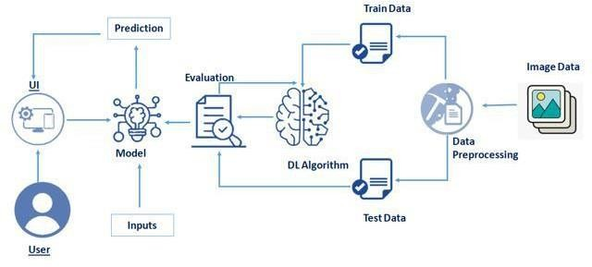

Table-1:Components&Technologies:

|  |  |  |  |
| --- | --- | --- | --- |
| **S.No** | **Component** | **Description** | **Technology** |
| 1. | UserInterface | HowuserinteractswithUserinterfacetoupload  image | Anaconda,jupyter,spyder,python.ext |
| 2. | Modelanalyses | Oncemodelanalysestheuploadedimage,thepredictionisshowcasedontheUI | Kaggle.com,data. gov,UCI |
| 3. | Datacollection | Createthedataset | Python,keras,numpy |
| 4. | DataPreprocessing-1 | ImporttheImageDataGeneratorlibrary | Python, keras,numpy |
| 5. | DataPreprocessing-2 | ConfigureImageDataGeneratorclass | Python,numpy,keras |
| 6. | DataPreprocessing-3 | ApplyImageDataGeneratorfunctionalitytoTrainsetandTestset | Python,numpy,keras |
| 7. | ModelBuilding-1 | ImportthemodelbuildinglibrariesandInitializingThemodel | Python,numpy,keras |
| 8. | ModelBuilding-2 | Addinglayersandconfigure | Python,numpy,keras |
| 9. | ModelBuilding-3 | Trainingandtestingthemodel,Optimizeandsavethemodel | Python,numpy,keras |
| 10. | ApplicationBuilding | Purposeof createanHTMLfileandBuildingPythoncode | HTML, python |
| 11. | Trainthe modelon IBM | CNNDevelopmentandintegrateitwiththeflaskApplication | IBMWatsont |

Table-2:ApplicationCharacteristics:

|  |  |  |  |
| --- | --- | --- | --- |
| **S.No** | **Characteristics** | **Description** | **Technology** |
| 1. | Open-SourceFrameworks | Opensourcesoftwareisthatbywhichthesourcecode orthebase code is usuallyavailablefor  modificationorenhancement. | Flask(python) |
| 2. | SecurityImplementations | By placing a filtration barrier between the targetedserverandtheattacker,theWAFisabletoprotectagainstattackslikecrosssiteforgery,crosssite  scriptingandSQLinjection. | e.g. SHA-256, Encryptions, IAMControls,OWASPetc. |
| 3. | ScalableArchitecture | Doesnot affecttheperformanceeventhoughusedbymanyusers. | Technologyused |
| 4. | Availability | Justifytheavailabilityofapplication(e.g.useof  loadbalancers,distributedserversetc.) | Technologyused |
| 5. | Performance | Designconsiderationfortheperformanceof the  application(numberofrequestspersec,useofCache,useofCDN’s)etc. | Technologyused |

References:

<https://c4model.com/>

<https://developer.ibm.com/patterns/online-order-processing-system-during-pandemic/><https://www.ibm.com/cloud/architecture>

<https://aws.amazon.com/architecture>

<https://medium.com/the-internal-startup/how-to-draw-useful-technical-architecture-diagrams-2d20c9fda90d>